Computer Science Department

Capstone Project Proposal

**Devils Grip**

[December 11th, 2020]

Name of an individual student or names of team members:

Steven Moody

Course Number and Course Title: GPH CSC 520

Project Advisor

Dr. Bo Hatfield

**Contents**

Student Objectives 3

Problem Specification 5

Solution Processes and/or Design 8

Requirement Collection and Analysis 8

Identifying Needs of Customers

Identifying Target Specifications

Use Case Diagram/Sequence Diagram/Activity Diagram

Generating Design Concepts x

Descriptions and Diagrams

Detailed Design x

Descriptions and Diagrams

Preliminary ER-Diagram (SQL) x

Or show visual design of hierarchical structures (NoSQL)

Benchmark Specification x

Tool List x

Time Schedule x

Grading Scheme for CSC521 x

List of Deliverables x

References (any useful support materials) x

**Student Objectives**

The computer Science capstone is intended to be a showcase of a students learned knowledge and the application of such knowledge in a way that is both easily represented as well as complete in nature. I believe my proposal, application, and presentation of my capstone project, Devils Grip, will satisfy both requirements. My project proposal consists of applying as well as furthering my knowledge in both the technical aspect as well as the ability to convey my proposal in an easily understandable way to those outside of the field (in terms of a product presentation).

In terms of technical knowledge objective, my proposal as a whole contains system-level structuring, a solutions process containing the technical steps I intend to take in order to complete my capstone project, as well as a tools list containing every piece of software I intend to use to do so. In doing this project I will be exposing myself to MySQL to develop a database for uninterrupted access to a high score leaderboard. I will also be learning about and utilizing the Unity game engine to help further my knowledge in the use of game engines. I will be programming in C# as well as Swift which will assist in diversifying my knowledge across various programming languages. Lastly, as a whole I will be furthering my knowledge in the Software Development Life Cycle in having to accomplish each phase of that on my own.

In terms of nontechnical objectives, I feel that there are a couple areas that I will be growing in doing this capstone project. For starters, in finding the problem that allowed me to justify the development of my game I have had to speak to members of my family to seek how to go about the development of Devils Grip. Due to the fact that they are not in our field, I had to learn how to speak in a non-technical aspect to help develop the requirements needed for this capstone project. To compound onto that, at each phase of the project I plan to have external testing done when possible and have to again rely on individuals who are not technically inclined and will not be conversing with me using technical terms. These two aspects will be furthering my ability to showcase software development and converse about as well as present products with/to clients once I am part the workforce.

In conclusion, I feel that the objective of developing Devils Grip are both technical and nontechnical. Both of which I feel are the goal of the Capstone proposal and completion/presentation of the Capstone project. From furthering my knowledge in the Software development Life Cycle to being able to talk about the product itself to a potential client, I feel that the project I am choosing to pursue will further these things very well.

**Problem Specification**

As we all know, COVID and the quarantine that ensued presented many of us with more time in both isolation as well as a lot of time away from our everyday lifestyles. I know that myself as well as my family decided to spend 1-2 nights a week playing board games or some sort of card game to help pass the time. At first, coming up with games to play was rather simple as we quickly went through our assortment of board games and transitioned to a variety of card games. However, this quickly became almost as boring and repetitive as quarantine itself. We then started to use Google to help us decide what games to play and started competing in games traditionally meant to be a single-person game to see who could complete it faster. That is when we stumbled upon the game known as Devil’s Grip.

Devil’s Grip is a solitaire based game in which a single person attempts to sort two shuffled decks of cards (with the aces removed) into 3 rows and 8 columns with each pile of cards consisting of a certain arrangement of same-suited cards in a sequential order. When completed successfully, the top row contains 8 piles of cards that each contain a 2, 5, 8, and a jack. The piles in the middle row should contain a 3, 6, 9, and queen. Lastly, each pile of cards within the bottom row should contain a 4, 7, 10, and a king. Breaking this down further, essentially there should be 24 individual piles of cards that each contain 4 cards of specific values in a specific order.

A player begins this game by shuffling both decks together and then taking the top 24 cards of the newly formed deck of cards and placing them in the arrangement described above (1 card in each position forming a 3 x 8 grid). Once these cards have been placed, the player can swap cards one at a time into new positions as necessary. For example, if there is a 3 of diamonds in the bottom row and a 4 of hearts in the middle row, the player could swap these cards so that each number is in its correct location on the grid. Similarly, the player can also begin stacking cards as necessary as well. Using the previous example, lets say that after the player moved these cards, they noticed a 6 of diamonds was in the top row. The player could take this 6 and place it on top of the 3 of diamonds they just moved previously. The now empty location where the 6 was, is replaced by a card from the top of the shuffled deck. Once this is completed the player then begins to flip over cards from the deck in sets of 3, only being able to use them in reverse order in which they were removed from the deck and fielding them as necessary, using the outlines rules as a guide.

Traditionally, this game ends when a player either successfully completes this arrangement with each row containing 8 piles of sorted, same-suit cards based on row or there are no moves left. If a player successfully sorts the cards, they receive a score of 0 which is the best possible score. However, if they still have cards left in the deck, the number of cards left equals their score. The lower a score the better.

Now that we have an understanding of the game, let me explain why I decided to make an application capable of running it. When my family was playing these card games, very often the surfaces that we were playing on would become cluttered and it would almost always become too cluttered to track the card arrangements. The surface area required to play this game was big and if playing on a floor we would also have to account for pets and such moving the piles and creating confusion. Often, we would use the app store from apple to download games and play them digitally to avoid this, however when we stumbled across Devil’s Grip we could not find an app that contained the game nor a website. That is when I got to thinking, why not create it myself? This app would allow for players to effortlessly play this game anywhere at any time as well as track their overall scores within the app itself so that if they were competing against someone else it would be easily tracked and shown. While this may seem simple in nature, I found it to be rather interesting that no one had bothered to include it within their app and during this time, the ability to pass time with effortless games seems to be very important.

**Requirement Collection and Analysis**

* Stakeholder Identification
  + Myself(Steven Moody); being made for family use (Mother, father, Sister, and girlfriend are clients); open for download by anyone with IOS device
* Requirement Lists for Requirement Specifications
  + Fully functional IOS application that includes specifically:
    - A functional home menu with “leaderboard”, “Options”, and “game start” buttons
    - A background that is neutral and appealing within the menu
    - The ability to choose difficulty
    - The ability to change card background
    - The ability to start over once a game has completed/no more moves remain
    - The ability to input name associated with each high score
    - The ability to Reset the Leaderboard if needed
  + Major goals/tests associated with the above requirements specifications include:
    - Client will download a functional IOS application of “Devils Grip” and will test that each feature listed above performs as expected. See Use Cases for a list of how these tests will be performed.
* Use cases
  + A functional IOS application
    - Client(s) will download game to IOS (Apple) capable device, upon completion will start the application and ensure they are brought to the home screen
  + A functional home menu with “leaderboard”, “Options”, and “game start” buttons
    - Clients(s) will start the IOS application and upon loading of the home screen will be presented with three SELECTABLE buttons. The first will be “Play”, the second will be “Options”, and the third will be “Leaderboard”
  + A functional PLAYABLE game
    - Upon accomplishing the above use cases, Client(s) will select the “Play” button at which time they will be brought to a new screen/view where cards will be shuffled/dealt and the player then can begin playing “Devils Grip” following the constraints (rules) of the game.
  + The ability to input name associated with each high score
    - Upon completion of the above Use Cases, once a game has been successfully finished or no further moves remain, Client(s) will be given the option to enter a 3 character high score name to be placed on the “Leaderboards” if applicable
  + The ability to start over once a game has completed/no more moves remain
    - Upon completion of the above Use Cases, Client(s) will be given the option to either begin a new game or return to the home screen menu
  + The ability to choose difficulty
    - At the home screen menu, Client(s) will select the “Options” button and when brought to a new screen will be allowed to choose the difficulty in which they want to play the game at
  + The Ability to Reset Leaderboard
    - At the home screen menu, Client(s) will select the “Options” button and when brought to a new screen will be allowed to reset the leaderboard
  + A background that is neutral and appealing within the menu
    - Upon loading into the application, Client(s) will be greeted by a background that is appropriate based a background of their choosing
  + The ability to change card background
    - At the home screen menu, Client(s) will select the “Options” button and when brought to a new screen will be allowed to choose the rear-facing card background of their liking based on the backgrounds the Client deems appropriate

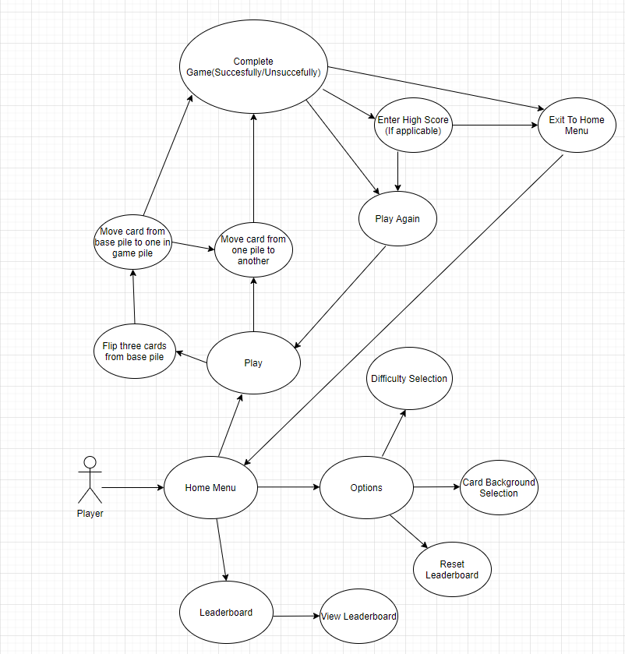**Sequence Diagram for “Devils Grip” application**